Brettenham SEND Information Report

Our school’s vision, values & ethos

At Brettenham, we welcome all children with SEND.

Our school’s vision is Harmony through Honesty, Awareness, Responsibility and Respect.

Together we will:

**Achieve, believe & grow**

**Share & celebrate success**

**Progress through commitment and resilience**

**Inspire independence & curiosity**

**Reach our potential**

**Enjoy our experiences**

How our vision, values and ethos relate to children with special educational needs

Our school’s vision statement of Harmony through Honesty, Awareness, Responsibility and Respect underpins everything we do throughout our school and is reinforced by our continued Inclusive practice. We provide a safe nurturing place for our children to thrive academically as well as socially and emotionally.

Our School

Brettenham is a two form entry Primary School with a Nursery. Children are aged 3-11 years. As we are a school situated in an area of diversity and significant deprivation, we strive to ensure that all children and their families receive high quality provisions to support both learning and personal wellbeing.

We strongly embrace the ethnic, cultural and religious diversity present at our school, and promote and celebrate it as much as possible.

Our Ofsted rating

Our current [Ofsted report](https://www.brettenhamprimaryschool.co.uk/attachments/download.asp?file=181&type=pdf) is ‘Good’.

How children are monitored and progress is tracked to ensure extra help is identified early

* All teachers assess each child every half term.
* All new admissions with English as an Additional Language are assessed using personalised targets are then set from.
* We hold termly Progress Meetings to track progress and highlight where support and intervention is needed.
* Concerns are highlighted and discussed with the parents, teachers and Inclusion Team.
* Inclusion Leader may carry out observations on the individual child.
* Other professionals may be invited into school to carry out assessment work and parents are consulted and kept informed at all times throughout this process.
* We use the graduated approach and work through the ‘Plan, Do, Review’ cycle to assess, discuss and plan for each individual child’s need.

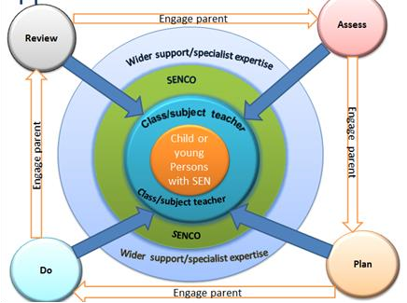

If a parent/career feels their child may have a special educational need, they can raise concerns at any time by making an appointment with the child’s class teacher and/or the Inclusion Team.

Common barriers to learning

There is a wide spectrum of difficulties that can lead to a child experiencing problems in learning and being assessed as having a special educational need. However, the spectrum can be narrowed into four areas of SEND, which helps us to plan their provision, and to focus on interventions that are relevant and of high quality.

Although four areas of primary need are identified here, it is recognised that many children and young people experience difficulties that do not fit easily into one area, and may have needs which span two or more areas. It is important that we carry out a detailed assessment of individual children and their situations to make accurate judgements of their needs and provide appropriate interventions.

The four primary areas of need are:

1. Communication and Interaction;
2. Cognition and Learning;
3. Social, Emotional and Mental health;
4. Sensory and/or Physical.

The main area of need for our children at Brettenham is ‘Communication and Interaction.’ We work closely with the Enfield Communication Advisory Support Service (ECASS) and Enfield Speech and Language Service.

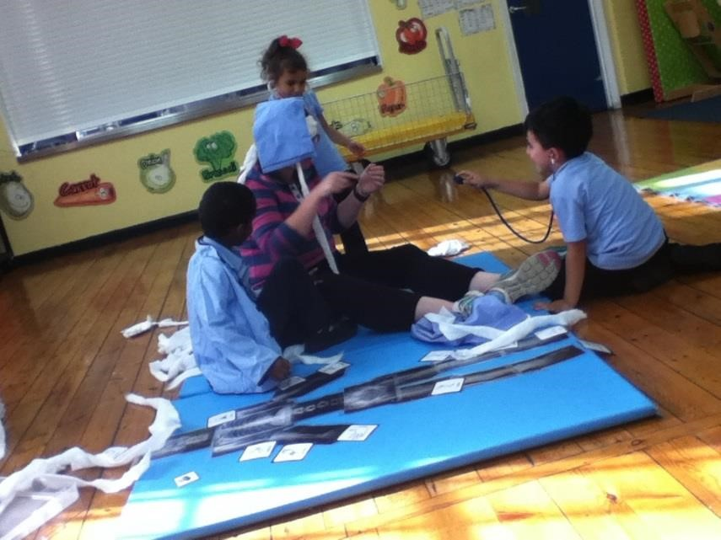

We also have an increasing number of children with a diagnosis of Autisim. We access outreach support from the [Enfield Advisory Service for Autism](https://www.enfieldasa.org.uk/) where required

What our school does to help children with special educational needs

* The class teacher is responsible for all children in their class and provides Quality First Teaching.
* The curriculum will be scaffolded to meet individual’s needs.
* At Brettenham we have a provision map which sets out any additional interventions that we are currently providing.
* Children are provided with appropriate interventions or individual programmes of support.
* Some children have an Educational, Health and Care Plan (EHCP). EHCPs are integrated support plans for children and young people with SEND from 0 to 25. They are focused on achieving outcomes and helping children and young people make a positive transition to adulthood, including into paid employment and independent living. They will be produced in partnership with parents, children and young people and will be based on a coordinated approach to the delivery of services across education, health and care.
* All interventions and additional support are carefully monitored by the class teacher and Inclusion Team for suitability and progress.
* Children will be set personalised targets in the form of an Individual Educational Plan (IEP). These targets are set with the class teacher, parents and child, and are reviewed termly.
* The school works closely with other professionals to ensure individual needs are met and the recommendations and advice, including specialist resources are all incorporated into the IEPs.
* Teaching Support Assistants (TSAs) are directed by the class teacher to target groups of children including those with SEND. They may also lead interventions and work with individual children providing some 1.1 support where necessary, but independence is always encouraged.
* The Inclusion Team supports the TSAs and meets with them regularly to track progress. TSAs are expected to assess interventions termly to monitor impact and progress – this will be discussed with Inclusion Team and class teacher.
* At Brettenham we have key members of staff who target children for specific needs:
  + Nurture Class team (Ms Gulen Ibrahim and Mrs Koulla Mappoura), supporting children with social, emotional and behavioural needs.
  + A Higher-Level Teaching Support Assistant (Ms Gulen), who is a trained Emotional Literacy Support Assistant (ELSA), supporting children with social, emotional and behavioural needs.
  + A Teaching Support Assistant (Ms Chappell), who uses art and yoga to support children with social, emotional and behavioural needs.
  + A teacher (Mrs Sandu), who leads the Read, Write Inc (RWI) intervention for all pupils.
  + A Higher-Level Teaching Support Assistant (Mrs Qamili), who supports children with English as an Additional Language (EAL).

How teachers match the curriculum to an individual child’s needs

* Planning lessons according to the specific needs of all groups of children in their class.
* Provide appropriate resources, scaffolding and make any reasonable adjustments to ensure all pupils can access learning.
* Incorporate any advice and recommendations provided by the Inclusion Leader and any other professional that may be involved with your child into the planning

[Our Curriculum](https://www.brettenhamprimaryschool.co.uk/page/?title=Our+Curriculum&pid=23)

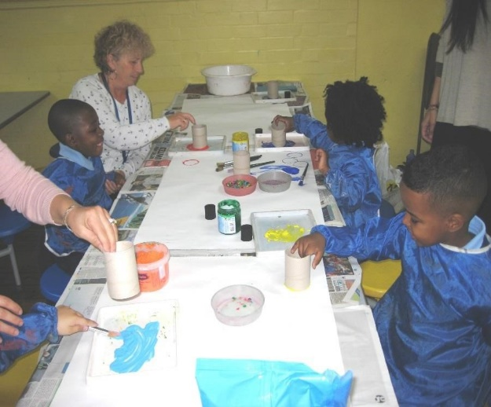

How our school’s resources are allocated and matched to children’s special educational needs

* The school has a School Development Plan, which includes identified training needs for all staff to improve teaching and learning of children including those with SEND.
* Performance Management Interviews are carried out, where specific training is discussed and booked.
* Trained support staff can implement the teacher’s adapted planning to support the needs of your child.
* Using the provision maps, the Inclusion Team will decide which children will require which interventions.
* The school SEND budget is allocated and planned for by the Head teacher and Senior Leadership team (including the Inclusion Leader) to ensure that the budget is spent according to need.
* The Local Authority provides external agencies that schools have access to. The provisions are carefully managed by the Inclusion Leader, as we only have access to a certain amount of visits per academic year as a resource. We can also use the school’s budget to ‘buy’ further time with the other agencies if necessary.
* All interventions and all external agencies work is reviewed at least termly to ensure the support is having an impact on the child.
* Senior Leadership Team attend Fair Access Panel to receive Local Authority support where required.

How your child’s progress is monitored and communicated to parents/careers

* Every half term the progress is reviewed formally in Reading, Writing and Maths. This progress is discussed during the termly progress meetings.
* Progress in other areas, such as attendance, engagement in learning and behaviour are also monitored.
* Parents are formally invited in termly to discuss progress with the class teacher and Inclusion Leader if requested. The teacher will produce a report for parents termly as part of the formal meeting. Parents can also make an appointment to meet the class teacher and/or Inclusion Leader throughout the year if they would like to discuss any concerns that they have.
* At the end of each Key Stage 2 all children are required to be formally assessed using the Standard Assessment Tests (SATs). This is a requirement from the government and the results are published nationally.
* In the Early Years Foundation Stage, regular meetings take place with parents to discuss the progress that the children are making and by the end of Reception the Early Years Foundation Stage Profile is completed on each child.
* The progress of children with an EHCP is formally reviewed at an Annual Review with all adults involved with the child’s education.
* IEPs are reviewed termly to ensure progress is being made for individuals.
* All interventions have a form of assessment to track progress and these are reviewed termly.
* If you child is still not making expected progress the school will contact you to discuss any concerns you may have, how school and home can work together to support your child and any further interventions or referrals to outside professionals that may need to be made.

Support offered for children’s overall health and well-being

Medical

* If your child has any medical needs the school Welfare Team will invite you in to discuss these. If a Care Plan is required the school nurse will support you to coproduce this with other professionals as required.
* The Care Plan will be updated with you at least yearly, but should any new developments occur parents are able to contact the school to discuss these and adjust the care plan accordingly.
* Parents can make an appointment with the school nurse to discuss any form of medical needs they have concerns about and she can offer advice and makes referrals if needed to other agencies.
* All medicines are carefully monitored and recorded by the Welfare Team.

Social and emotional well-being

* Your child’s general well-being and pastoral care is very important to us and sharing of parents concerns with the class teacher will help us all work together.
* We provide ‘Active Lunchtimes’ to encourage all children to be active and to develop their physical, social and behavioural skills
* We offer a Breakfast Club every morning to ensure children can access a healthy breakfast
* We offer ‘Circle Time’ activities, which all staff have had SWERRL training on to support pupils with Social, Emotional and Mental Health.
* We provide a strong [Mental Health and Wellbeing](https://www.brettenhamprimaryschool.co.uk/page/?title=Mental+Health+and+Wellbeing&pid=73) curriculum which includes Personal, Social, Health and Economic ([PSHE](https://www.brettenhamprimaryschool.co.uk/page/?title=PSHE&pid=62)) and Social, Moral, Spiritual and Cultural ([SMSC](https://www.brettenhamprimaryschool.co.uk/page/?title=SMSC&pid=63)).
* We also implement the UNICEF, Rights Respecting Schools work and have achieved Gold of the [Rights Respecting Schools Award](https://www.brettenhamprimaryschool.co.uk/page/?title=UNICEF+Rights+Respecting+Schools+Award&pid=71).
* We have a qualified ELSA (Emotional Literacy Support Assistant) to deliver intervention to individuals
* We have a part-time Nurture Class as an intervention to support children with SEMH needs

Attendance

* It is very important that your child has good attendance, so that they can make good progress in all areas.
* School attendance is carefully monitored by the Attendance Manager in conjunction with the school’s Educational Welfare Officer. Working together will ensure the best possible outcomes.
* We offer weekly awards – termly class prizes and certificates and yearly medal ceremonies.

Child’s Views

* Each year the children with SEND are invited to share their views by completing a questionnaire. This helps the school to find out how they are feeling and for them to think about their areas of strength and where they may need further support.
* We have regular pupil interviews each term to determine pupils’ understanding of the curriculum.

Support provided to develop independence and prepare children for adulthood

* Although support is provided where needed, children are encouraged to be independent. This is promoted through the use of child/ need specific resources.
* Children’s work is scaffolded in classrooms to ensure that they are able to complete task independently, but with support were necessary.
* Children are continuously encouraged to develop their individual self-help skills.
* Rights Respecting work and Spiritual, Moral, Social and Cultural curriculum is used to develop the ‘whole child’ and make them aware of their place in the wider community
* Specific speech and language programmes and groups are in place to help children to communicate effectively in the wider environment
* We also work with other outside agencies to provide mentoring and support for all children with specific needs.

Arrangements in place for Looked After Children with SEND

* Each child will have an individual LAC review meeting as well a multiagency SEND review meeting held by a member of the Inclusion Team to discuss the needs of the child. Present at this meeting may be Parent/Carer/Guardian, Social Services, an Educational Psychologist and a Speech and Language Therapist.
* With extra pupil premium received, all trips, Out of School Hours Learning activities (OSHL) and breakfast club are paid for.
* School uniform, PE kits and other resources needed are also subsidised or paid for by the school.
* Our schools Designated Teacher for LAC children is Mrs Taylor.

Specialist services and expertise available and accessed by our school

The school has access to the following external agencies:

* Educational Psychology Service (EP)
* Speech and Language Service (SALT)
* Enfield Communication Advisory Support Service (ECASS)
* Children and Adolescent Mental health Service (CAMHS)
* Child Development Team (CDT)
* Early Years Social Inclusion Team (EYSI)
* Children and Young Persons’ Service (EYPS)
* Strengthening Wellbeing, Emotional health, Relationships and Readiness for Learning Service (SWERRL)
* Multi-Agency Support Hub (MASH)
* Physiotherapy and Occupational Therapy
* Every Parent and Children (EPC)
* Edmonton Community Partnership (ECP)
* School and Early Years Improvement Service
* Joint Services for Children with Disabilities
* School Nurse
* Hearing Impaired Service
* Outreach Services from the Special schools including West Lea, Russet House, Waverly and Joseph Clarke

Further information regarding support provided by external agencies can be found through [Enfield's local offer for SEND](https://www.enfield.gov.uk/services/children-and-education/local-offer).

Training for support staff

We have had a focus on Autism over the last academic year and all staff including, teachers, support staff and play leaders are or have received bespoke training from the Enfield Advisory Service for Autism.

As we work with other colleagues from other agencies, particularly the Speech and Language Therapy Service, the staff have time to work with them as a form of training and personal development to increase their skills when working with individual children.

Access to activities outside the classroom

All children are included in all activities with their peers including all trips. Before any trip a Risk Assessment is completed to ensure accessibility and additional adults may be provided on an individual needs basis.

Access to our school environment

The ground floor of our school is wheelchair accessible through two entrances, however the first floor is not. The classrooms are all clearly lit and kept clear and tidy, as are the corridors. All classrooms have been fitted with interactive whiteboards.

How we prepare for children joining and leaving our school

If your child is joining the school:

* A home visit may be carried out.
* The family are offered a tour of the school and to meet key adults before the child starts.
* If needed, there will be a transition meeting between the previous setting and Brettenham to share information and to set up a transition plan.
* If appropriate a member of the Inclusion team will visit your child in their current setting.
* When the child starts they will be given a buddy to support them in class.

If you child is transferring to another school:

* A social story may be designed to support the child to prepare for the move.
* Liaison and information sharing with the other school in the form of a meeting with parents involved.
* A transition plan may be set up including possible pre-visits to the new school

Transition to Secondary Schools:

* A member of the Inclusion Team will invite the secondary staff in to discuss the child and share information.
* Some individual children may require specific interventions to help them to prepare for secondary schools such as a speech and language programme to develop their social skills.
* Secondary schools offer taster days so the children can visit their new school.
* Some children may require further visits to the new school and these will be planned for according to need.

How parents are involved in school life

* You are encouraged to discuss any concerns at the first opportunity with your child’s class teacher.
* Parents are expected to attend all termly parents open days/evenings to discuss the progress of their children.
* In the Early Years Foundation Stage regular meetings take place with parents to discuss the progress that the children are making
* Tapestry is the platform used for each child’s online journal. Parents/cares can post and communicate with the class teacher through this platform.
* The progress of children with an EHCP is formally reviewed at an annual review with all adults involved with the child’s education.
* IEPs are reviewed termly to ensure progress is being made for individuals.
* All interventions have a form of assessment to track progress and these are reviewed termly.
* You are welcome to make an appointment with the Inclusion Leader and any member of the Senior Leadership team, including the Headteacher.
* We have a team of Parent Representatives for you to make contact with.
* Parents are invited to their children’s class assemblies through the school year.
* If you first language is not English, you are encouraged to bring along a translator and if this is not possible the school can provide translators.

Who to contact for further information

* Your first point of contact should be the class teacher.
* A member of the Inclusion Team is available by appointment at any time to discuss your child’s progress and to talk about concerns that you may have.
* All outside agencies who work with your child are available for you to meet and you will also receive information in the form of a report if they have carried out any formal assessments.
* The Assistant Headteacher for Inclusion is Ms Claire Taylor (her role within this is the SEN Co-ordinator). The contact number for the Inclusion Team is 020 8345 6055.

Who to contact to make a complaint

Please see our school’s [Complaints Policy](https://www.brettenhamprimaryschool.co.uk/page/?title=Complaints&pid=41).

Our offer to children with special educational needs and disabilities was updated September 2024. It will be reviewed September 2025.